Mansurbek Satarov

Doctor Tai Cleveland

COMP 3324

Week 2 – Lab 1 – Web Goat Application

3/12/2023

Web Goat Application

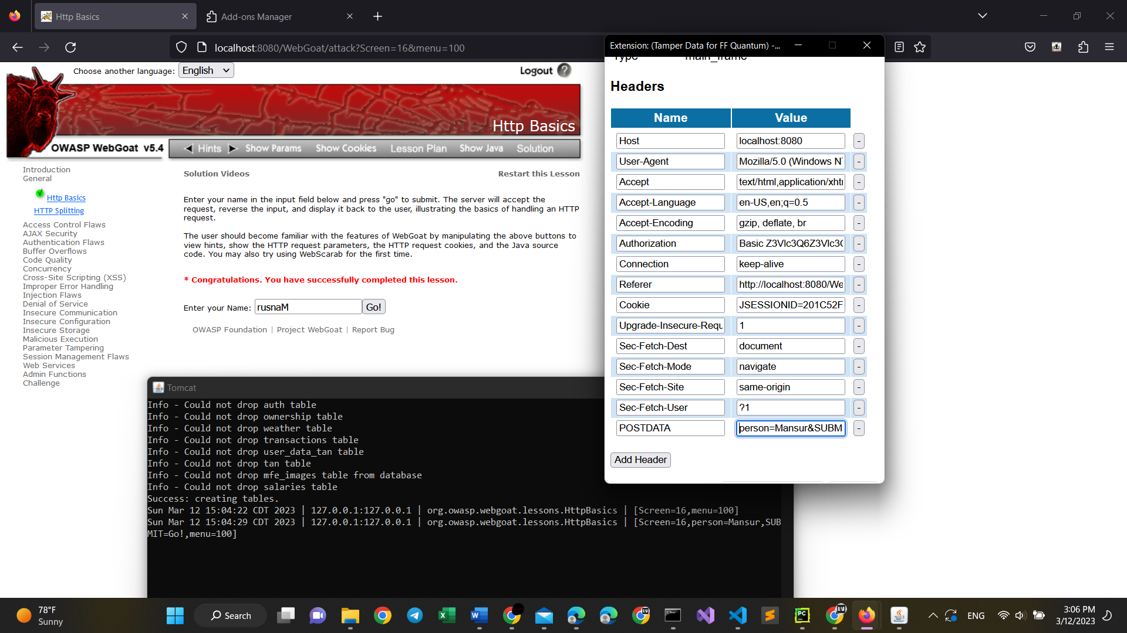

1. This application was done on Windows 11 on the laptop of my Friend
2. I use MacOS
3. We had problems with finding tamper extension: so, we used another extension which makes the same functions
4. After inputting the name, the Tomcat Java application added a new line.